**IOT LAB**

**Program No - 11**

**Program Title – TILT SENSOR AND LED.**

**Aim – Design a smart handling system.**

**Hardware Required -**

* Arduino Board
* Led bulb
* Resistor – 240 ohm x 2
* Tilt sensor
* Jump wires

**Circuit Diagram –**

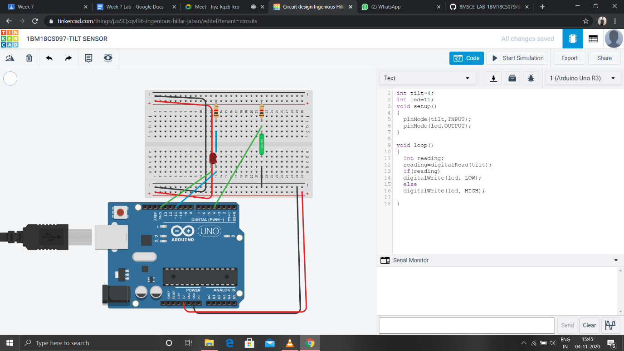

**Code:**

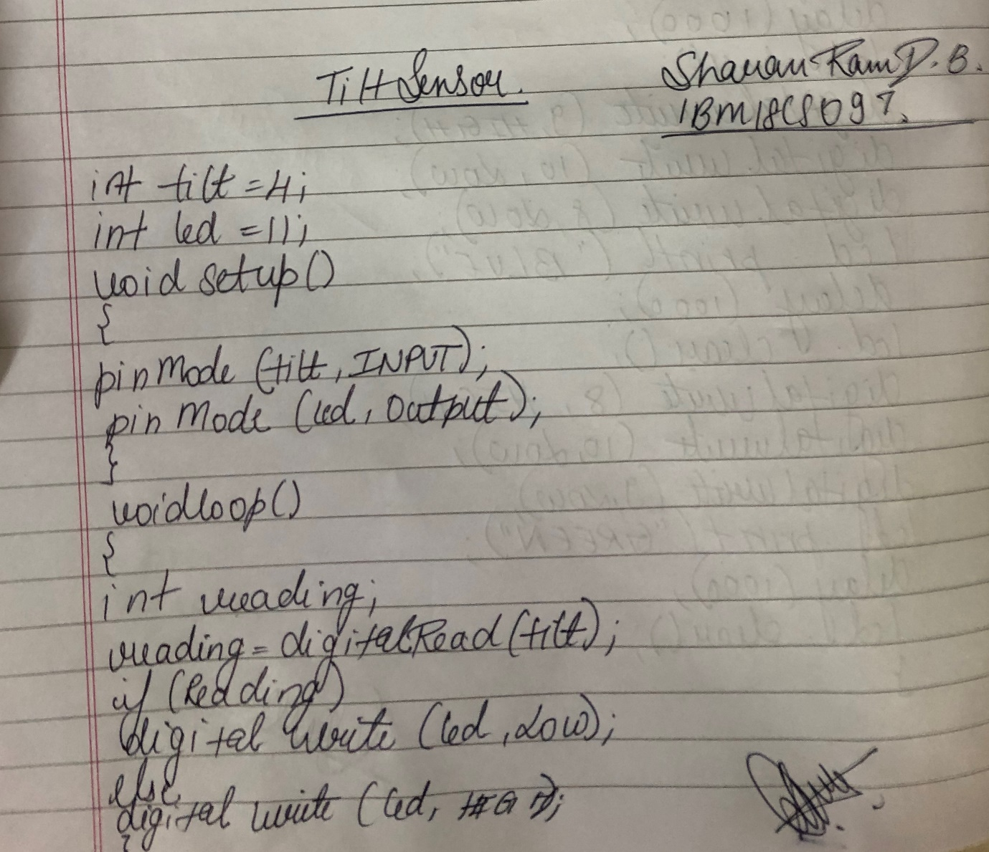

**Observation /Output –**

**The led was lit when the sensor went through a tilt.**